|  |
| --- |
| **www.enosislearning.com** |
| 5.2 SQL ASSIGNMENTS |
| This assignment is related to CLAUSES USING JOINS, CLAUSES OF SQL SERVER. (Use Advance clauses like Ranking, CUBE etc for solving this) |

|  |
| --- |
|  |

CREATE THE FOLLOWING TABLE DESCRIBED BELOW AND INSERT THE DATA AS GIVE BELOW.

# Queries for Relational Model

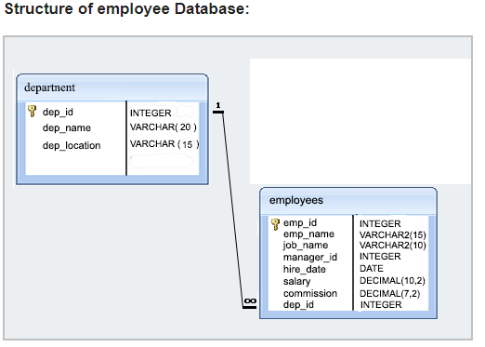

|  |
| --- |
| DROP TABLE DEPARTMENT  DROP TABLE EMPLOYEES  CREATE TABLE DEPARTMENT  (  DEPT_ID INT PRIMARY KEY,  DEPT_NAME VARCHAR(100),  DEPT_LOCATION VARCHAR(100)  )  INSERT INTO DEPARTMENT VALUES(1,'IT','PUNE')  INSERT INTO DEPARTMENT VALUES(2,'HR','MUMBAI')  INSERT INTO DEPARTMENT VALUES(3,'ADMIN','MUMBAI')  INSERT INTO DEPARTMENT VALUES(4,'SECURITY','PUNE')  INSERT INTO DEPARTMENT VALUES(5,'FINANCE','MUMBAI')  CREATE TABLE EMPLOYEES  (  EMP_ID INT PRIMARY KEY,  EMP_NAME VARCHAR(100),  JOB_NAME VARCHAR(100),  MANAGER_ID INT FOREIGN KEY REFERENCES EMPLOYEES(EMP_ID),  HIRE_DATE DATETIME,  SALARY DECIMAL(10,2),  COMMISSION DECIMAL(7,2),  DEPT_ID INT FOREIGN KEY REFERENCES DEPARTMENT(DEPT_ID)  )  INSERT INTO EMPLOYEES VALUES (1,'SUNIL','MANAGER',NULL,'10/10/2018',60001,1000,1)  INSERT INTO EMPLOYEES VALUES (2,'KAPIL','MANAGER',NULL,'05/10/2018',80012,1000,2)  INSERT INTO EMPLOYEES VALUES (3,'SAMIR','CLERK',2,'10/10/2018',11000,1000,2)  INSERT INTO EMPLOYEES VALUES (4,'KRUTIKA','CLERK',2,'05/10/2018',12000,1000,2)  INSERT INTO EMPLOYEES VALUES (5,'YASIKA','CLERK',2,'10/10/2019',13000,5000,2)  INSERT INTO EMPLOYEES VALUES (6,'SONAL','CLERK',2,'05/10/2019',14000,6000,2)  INSERT INTO EMPLOYEES VALUES (13,'RAJESH','CLERK',NULL,'10/10/2000',15000,1000,1)  INSERT INTO EMPLOYEES VALUES (14,'UMESH','CLERK',NULL,'05/10/1999',16000,1000,2)  INSERT INTO EMPLOYEES VALUES (15,'YAMIN','CLERK',NULL,'10/10/1998',17000,5000,1)  INSERT INTO EMPLOYEES VALUES (16,'KAMINI','CLERK',NULL,'05/10/1997',18000,6000,2)  INSERT INTO EMPLOYEES VALUES (113,'SUJANAN','CLERK',1,'10/10/2000',12500,1000,1)  INSERT INTO EMPLOYEES VALUES (114,'ANJANA','CLERK',1,'05/10/1999',13500,1000,1)  INSERT INTO EMPLOYEES VALUES (115,'TEJAL','CLERK',1,'10/10/1998',10500,5000,1)  INSERT INTO EMPLOYEES VALUES (116,'AKSHAY','CLERK',1,'05/10/1997',10600,6000,1)  INSERT INTO EMPLOYEES VALUES (213,'SUJANAN','CLERK',2,'10/10/2000',12001,1000,2)  INSERT INTO EMPLOYEES VALUES (214,'ANJANA','CLERK',2,'05/10/1999',13001,1000,2)  INSERT INTO EMPLOYEES VALUES (215,'TEJAL','CLERK',2,'10/10/1998',10001,5000,2)  INSERT INTO EMPLOYEES VALUES (216,'AKSHAY','CLERK',2,'05/10/1997',10045,6000,2)  INSERT INTO EMPLOYEES VALUES (313,'JAYESH','ANALYST',2,'10/10/2000',12011,1000,2)  INSERT INTO EMPLOYEES VALUES (314,'TAJESH','ANALYST',2,'05/10/1999',13011,1000,2)  INSERT INTO EMPLOYEES VALUES (315,'MANGESH','ANALYST',2,'10/10/1998',10451,5000,2)  INSERT INTO EMPLOYEES VALUES (316,'KALPESH','ANALYST',2,'05/10/1997',10565,6000,2)  SELECT * FROM EMPLOYEES |

1. Write a query in SQL to display the unique designations for the employees.
2. Write a query in SQL to list the employees who joined before 1991
3. Write a query in SQL to display the average salaries of all the employees who works as ANALYST
4. Write a query in SQL to display all the details of the employees whose commission is more than their salary.
5. Write a query in SQL to list the employees who are either CLERK or MANAGER.
6. Write a query in SQL to list the employees who are working either MANAGER or ANALYST with a salary range between 2000 to 5000 without any commission
7. Write a query to list average salaries per department, highest salary per department.
8. Write a query to find departments having more than 20 employees.
9. query in SQL to list the employees who joined

---before 2001

-- in month of Feb

1. find employees having salary greater than avg salary of their dept and second letter of their name has 'a'.
2. Find Highest Salary Holder Employee details of Each Dept in a single query
3. Find Second Highest Salary Holder Employee details of Each Dept in a single query
4. Find Top 3 Highest Salary Holder of Each Dept in a single query
5. Find Top 5 Highest Salary of Each Dept in a single query
6. Find Bottom 3 Highest Salary Holder of Each Dept in a single query